
LESSON NOTE | DETAILED EXPLANATORY NOTES
BIOENERGY
BIOMASS & BIOFUELS
GRADE 12 - BIOLOGY
■ ■ ■

What is Bioenergy?
Bioenergy is energy obtained from biomass -recently living material such as plants, animals and their wastes. All of this energy originally came from the Sun: green plants capture sunlight during photosynthesis and store it as chemical energy in the molecules that make up their bodies. Because plants can be regrown, biomass is a renewable source of energy, unlike coal, oil and gas.
This lesson looks at what biomass is, how it stores the Sun's energy, how it is turned into biofuels -bioethanol, biodiesel and biogas -and the advantages, limitations and uses of these fuels, especially in Papua New Guinea.
Why Biomass and Biofuels Matter
- They are a renewable source of energy that can be regrown.
- They can be roughly carbon-neutral, helping to limit climate change.
- They make use of waste materials such as crop residues and animal dung.
- They offer energy independence for rural and developing communities.
Biomass & Biofuels
Key Learning Outcomes
By the end of this lesson, students should be able to:
- Define biomass and biofuel and explain how biomass stores the Sun's energy.
- Describe the main sources of biomass.
- Describe the three main biofuels -bioethanol, biodiesel and biogas -and how each is made.
- Explain why biofuels are considered renewable and roughly carbon-neutral.
- Discuss the advantages and disadvantages of biofuels and their use in Papua New Guinea.
What is Biomass?
Biomass is organic material from recently living things that stores chemical energy. During photosynthesis, plants convert carbon dioxide and water into glucose using light energy; the glucose is built into starch, cellulose, oils and other molecules that make up the plant's biomass. When we use biomass for energy, we are really releasing the solar energy that was stored inside it. Common sources of biomass include:

- Wood and forestry residues -firewood, sawdust and offcuts.
- Energy crops -sugarcane, corn, oil palm and coconut grown for fuel.
- Agricultural residues -crop stalks, husks and bagasse (the fibre left after crushing sugarcane).
- Animal and human waste -dung and food waste, used to make biogas.
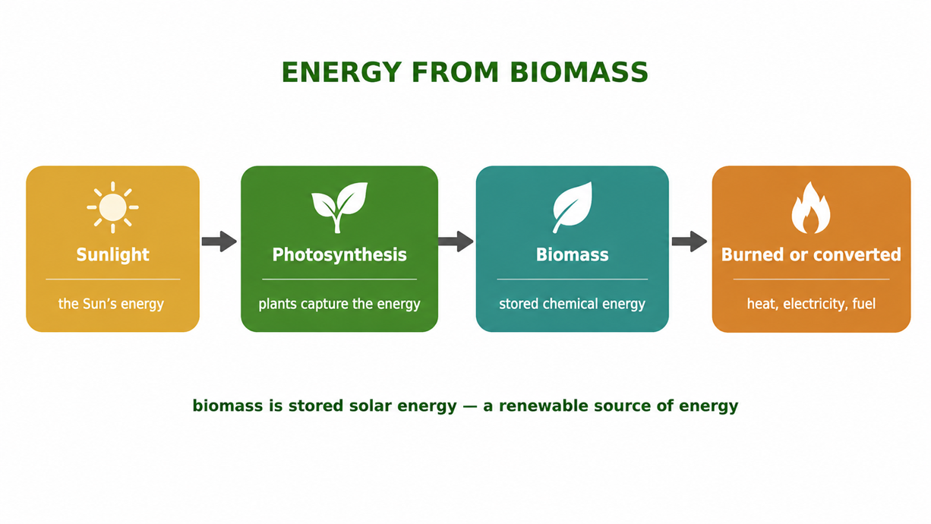
Figure 1: Biomass is stored solar energy -captured by photosynthesis and released when the biomass is used.

Terminologies and Concepts
Useful terms for this topic:
- Biomass: organic material from recently living things that stores chemical energy.
- Bioenergy: the energy obtained from biomass.
- Biofuel: a fuel made from biomass (e.g. bioethanol, biodiesel, biogas).
- Fermentation: the breakdown of sugars by yeast to make ethanol (and CO₂), without oxygen.
- Anaerobic digestion: the breakdown of organic waste by bacteria without oxygen, making biogas (methane).
- Renewable: a resource that can be replaced as fast as it is used.
- Carbon-neutral: releasing only as much CO₂ as was recently absorbed from the air.
From Biomass to Energy
Biomass can be used for energy in two main ways. The simplest is direct combustion -burning wood or crop residues to release heat for cooking, heating or generating electricity. The more advanced way is to convert the biomass into biofuels -liquid or gas fuels that are easier to store, transport and burn cleanly in engines and stoves. It is these biofuels that make biomass a practical modern energy source.
The Three Main Biofuels
There are three biofuels students should know, each made from a different kind of biomass by a different process:
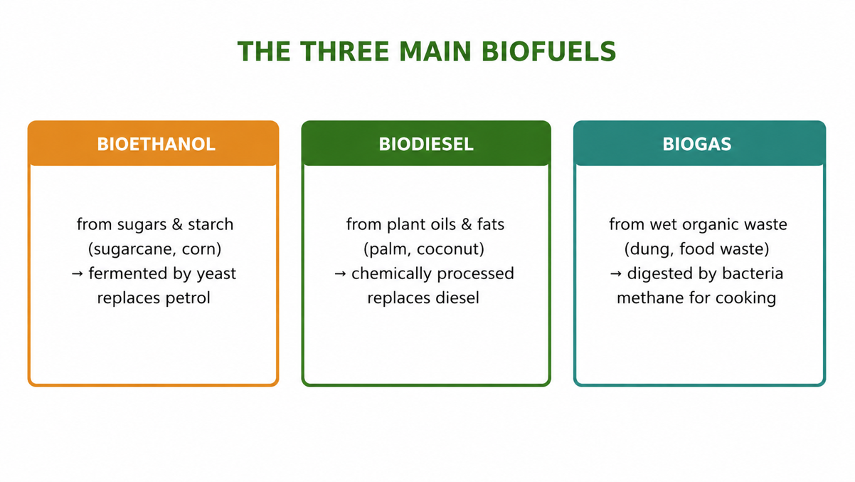
Figure 2: The three main biofuels -bioethanol, biodiesel and biogas -and what each is made from.
Bioethanol
Bioethanol is an alcohol made by fermenting sugars and starches from crops such as sugarcane and corn. Yeast breaks the sugar down into ethanol and carbon dioxide (C₆H₁₂O₆ → 2 C₂H₅OH + 2 CO₂). The ethanol is distilled and blended with petrol to fuel vehicles.
Biodiesel
Biodiesel is made from plant oils and animal fats -in PNG especially palm oil and coconut oil. The oil is chemically processed (transesterification) into a fuel that can replace ordinary diesel in engines and generators.
Biogas
Biogas is made by the anaerobic digestion of wet organic waste -animal dung, food scraps and sewage -by bacteria in a sealed tank (a digester). The gas produced is mainly methane, which is burned for cooking, lighting and generating electricity, while the leftover slurry makes a good fertiliser.
Biofuels and the Carbon Cycle
Burning any fuel releases carbon dioxide. But biofuels are considered roughly carbon-neutral because the CO₂ they release was only recently absorbed from the air by the plants as they grew. In fossil fuels, the carbon was locked away for millions of years, so burning them adds old carbon to the atmosphere; with biofuels, the carbon simply cycles back and forth. This is why replacing fossil fuels with biofuels can help reduce the build-up of greenhouse gases.
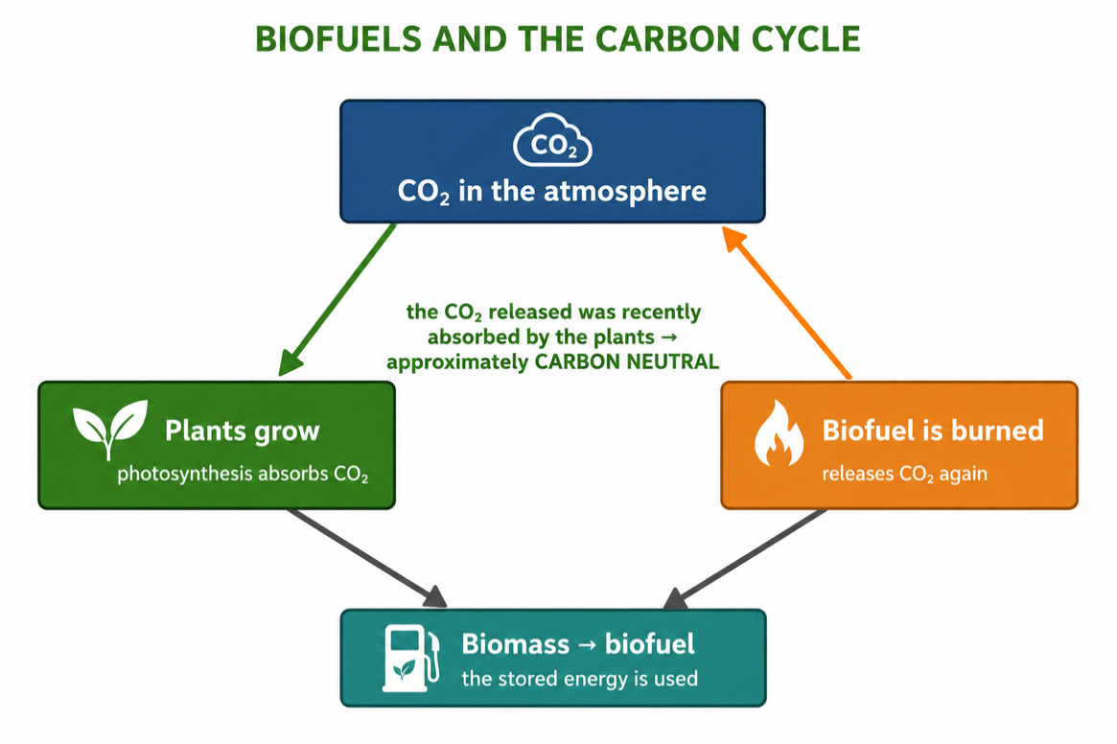
Figure 3: Biofuels are roughly carbon-neutral -the CO₂ released was recently taken in by the growing plants.
Advantages and Disadvantages
Advantages | Disadvantages
Renewable -biomass can be regrown | Growing fuel crops competes with food crops for land
Roughly carbon-neutral | Clearing land (e.g. forest) can release carbon and harm habitats
Uses waste materials and residues | Processing biofuels can be costly and energy-intensive
Supports rural energy and local jobs | Yields per hectare are lower than fossil fuels

Worked Example -Fermentation for Bioethanol
Yeast ferments the sugar glucose to make bioethanol:
C₆H₁₂O₆ → 2 C₂H₅OH + 2 CO₂
So each molecule of glucose produces two molecules of ethanol (the biofuel) and two of carbon dioxide. The ethanol is then separated by distillation and blended with petrol -showing how a simple biological process turns a crop such as sugarcane into a usable fuel.
Why This Matters
- Renewable energy -biofuels reduce dependence on limited fossil fuels.
- Climate -being roughly carbon-neutral, they help limit greenhouse-gas build-up.
- Energy waste -they turn crop residues and animal waste into useful fuel and fertiliser.
- Development -they can power rural communities and create local industries and jobs.
PNG Context Example
Papua New Guinea has strong potential for biomass and biofuels. Palm oil and coconut (copra) oil can be made into biodiesel for vehicles and generators; sugarcane can be fermented into bioethanol; and village-scale biogas digesters can turn animal dung and food waste into cooking gas, cutting the need for firewood and reducing indoor smoke. Wood is already the main cooking fuel for most households. Developing these renewable fuels could improve energy access, food and energy security, and rural livelihoods across the country.
References & Related Documents
Source Documents
- STEM Biology Syllabus -Grade 12. Thema: Energy; Module 12.1 Bioenergy (Biomass and Biofuels). Department of Education, PNG.
- Biology Standards-Based Syllabus, Grades 11 & 12 (PNG SBC 2020) -Strand 2: Life; examine the chemical reactions of photosynthesis and cellular respiration and the cycling of energy; explain how matter and energy flow through living systems.
Further Reading & References
- OpenStax Biology -Photosynthesis; Energy and Metabolism. https://openstax.org/books/biology
- Khan Academy -Renewable energy and biofuels. https://www.khanacademy.org/science/biology

